CLASS DIAGRAM

Lab 3 qn no 1:

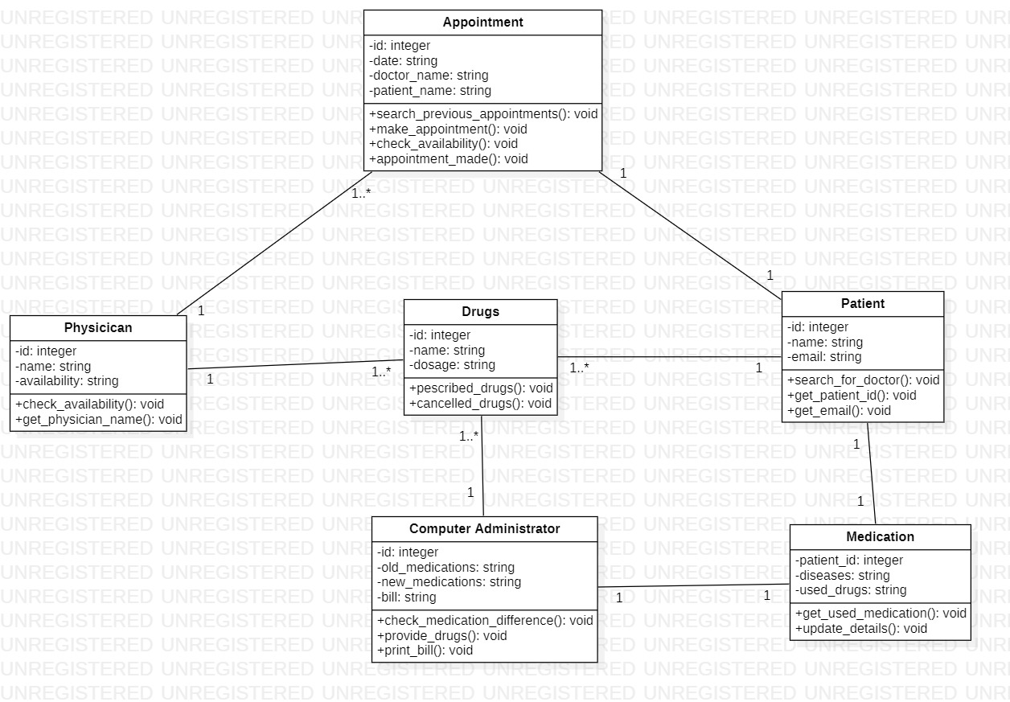

Lab 3 qn no 2:

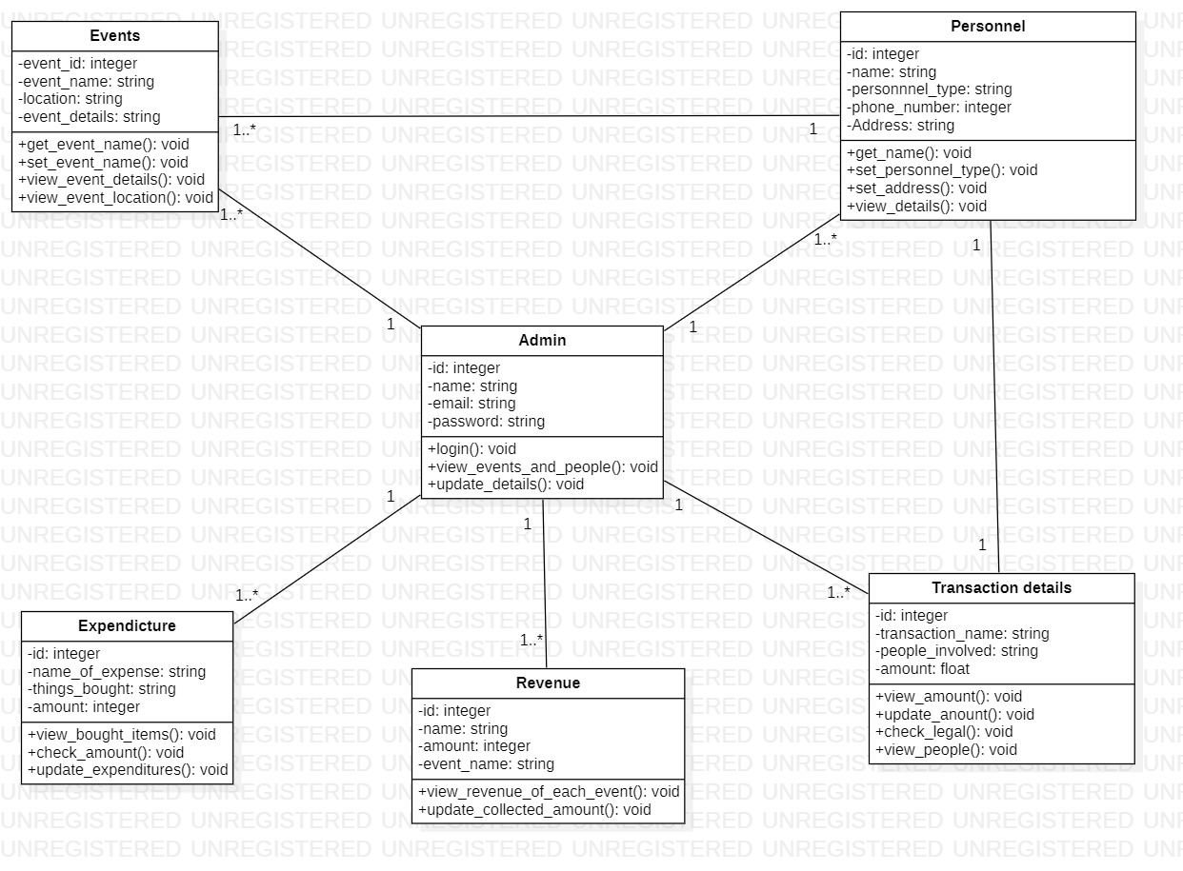

SEQUENCE DIAGRAM

Lab 4. Qn no 1

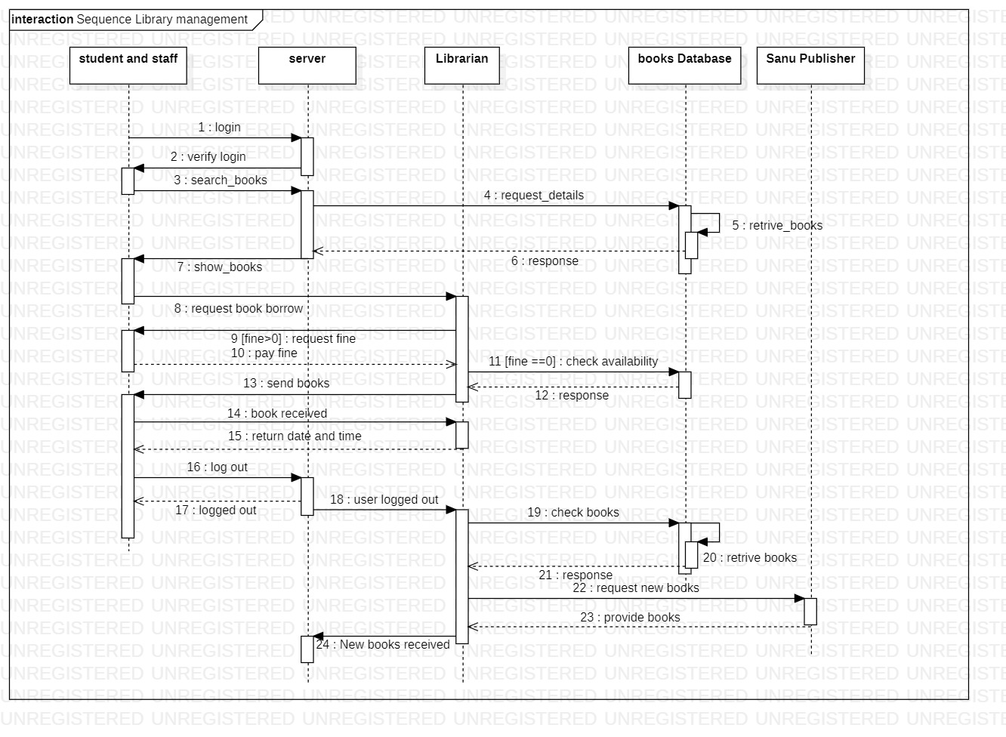

Lab 4 : qn no 2

